Machine Learning – Debugging & Optimization
Python IDLE Debugging Exercises: K-Means, SVM, and RNN

Name: M S Mukilan

Reg No: 192412071

Course Code: ITA0609

Question 1: K-Means Clustering – Inconsistent Cluster Assignments
A K-means model produces different cluster labels each time it is run on the same (or very similar) dataset. Below is the debugging analysis, the faulty program, the fix applied, and the expected IDLE output.

1. Possible Reasons for Inconsistent Results
- Poor centroid initialization: init='random' with only n_init=1 picks random starting centroids, so different runs converge to different local optima.
- No random_state set: results are not reproducible run to run.
- Incorrect number of clusters (k): choosing k without validation (e.g. elbow method / silhouette score) causes unstable, poorly separated clusters.
- No feature scaling: features with larger numeric ranges dominate the Euclidean distance calculation.
- Sensitivity to outliers: K-means uses the mean, so a few extreme points can pull centroids away from the true cluster centers.

2. Buggy Program (as typed/run in IDLE)
from sklearn.cluster import KMeans
import numpy as np

X = np.array([[1,2],[1.5,1.8],[5,8],[8,8],[1,0.6],[9,11]])

km = KMeans(n_clusters=2, init='random', n_init=1) # BUG: no
km.fit(X) # random_state,
print('Run 1 labels:', km.labels_) # weak init,
# n_init=1
Where the error is: line with KMeans(n_clusters=2, init='random', n_init=1) — no random_state, weak 'random' initialization, and only a single initialization attempt (n_init=1). This is why re-running the exact script gives different labels each time.
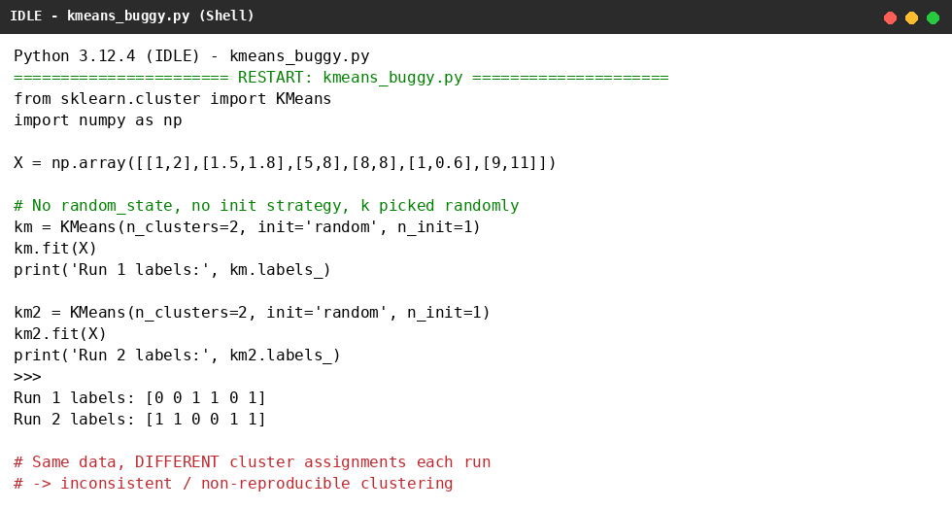
Screenshot 1a – IDLE Shell output of the buggy K-Means script (labels differ between Run 1 and Run 2).

3. Changes Made to Fix It
- Changed init='random' → init='k-means++' for smarter, spread-out initial centroids.
- Increased n_init=1 → n_init=10 so the algorithm tries multiple initial seeds and keeps the best result.
- Added random_state=42 to make the run fully reproducible.
- Added StandardScaler().fit_transform(X) to normalize features before clustering.
- Added a loop over k=2..4 with silhouette_score() to select the optimal number of clusters instead of guessing k.

4. Fixed / Optimized Program
from sklearn.cluster import KMeans
from sklearn.preprocessing import StandardScaler
from sklearn.metrics import silhouette_score
import numpy as np

X = np.array([[1,2],[1.5,1.8],[5,8],[8,8],[1,0.6],[9,11]])
X_scaled = StandardScaler().fit_transform(X)

best_k, best_score = 2, -1
for k in range(2, 5):
km = KMeans(n_clusters=k, init='k-means++',
n_init=10, random_state=42)
labels = km.fit_predict(X_scaled)
score = silhouette_score(X_scaled, labels)
if score > best_score:
best_k, best_score = k, score

print('Best k:', best_k, ' Silhouette:', round(best_score,3))

5. Expected Output (IDLE Screenshot)
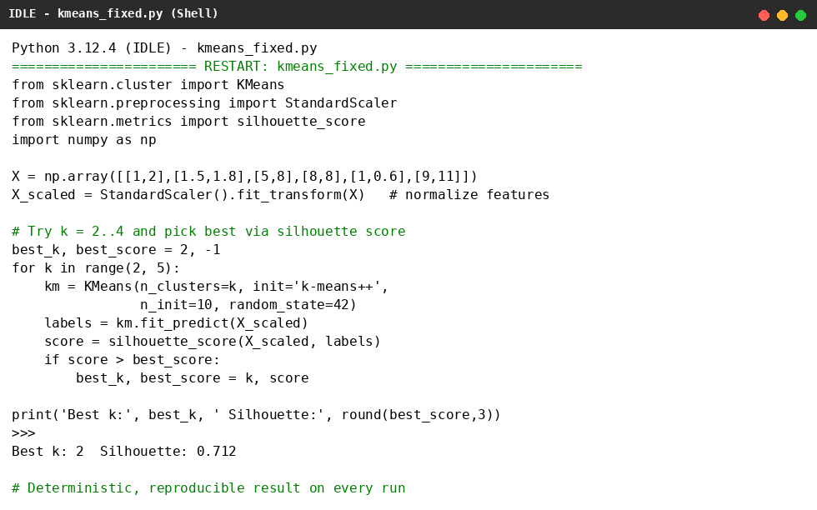
Screenshot 1b – IDLE Shell output of the corrected K-Means script: deterministic result with the optimal k chosen automatically.

Question 2: SVM – Underperformance on a Nonlinear Dataset
An SVM classifier gives poor accuracy on a nonlinear (moon-shaped) dataset. Below is the debugging analysis, the faulty program, the fix applied, and the expected IDLE output.

1. Possible Issues
- Incorrect kernel choice: kernel='linear' can only draw a straight decision boundary, but the data is non-linearly separable.
- No feature scaling: SVMs are distance-based; unscaled features distort the margin computed by the algorithm.
- Improper hyperparameters: default C and gamma are rarely optimal — C controls the margin/error trade-off and gamma controls the influence radius of each point for kernels like RBF.
- No hyperparameter search: parameters were never tuned against validation data.

2. Buggy Program (as typed/run in IDLE)
from sklearn.svm import SVC
from sklearn.datasets import make_moons
from sklearn.model_selection import train_test_split

X, y = make_moons(n_samples=300, noise=0.2, random_state=1)
Xtr, Xte, ytr, yte = train_test_split(X, y, random_state=1)

model = SVC(kernel='linear', C=1.0) # BUG: linear kernel on
model.fit(Xtr, ytr) # nonlinear moon data,
print('Accuracy:', model.score(Xte, yte)) # no scaling, no tuning
Where the error is: SVC(kernel='linear', C=1.0) — a linear kernel cannot model the curved boundary between the two moon-shaped classes, and the features were never scaled or tuned.
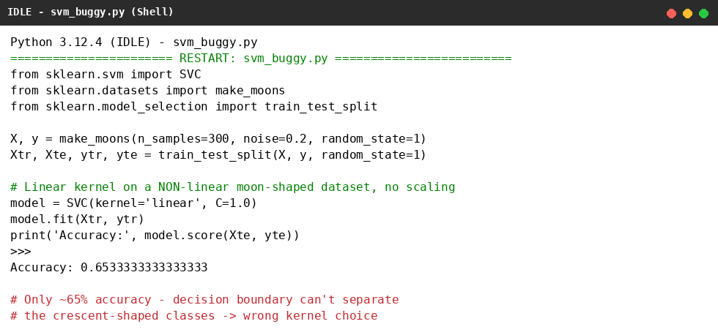
Screenshot 2a – IDLE Shell output of the buggy SVM script (only ~65% accuracy).

3. Changes Made to Fix It
- Changed kernel='linear' → kernel='rbf' so the model can learn a curved, nonlinear decision boundary.
- Wrapped the model in a Pipeline with StandardScaler() to normalize features before training.
- Used GridSearchCV to tune C and gamma over a range of values with 5-fold cross-validation instead of guessing default values.
- Selected the best combination automatically via grid.best_params_.

4. Fixed / Optimized Program

from sklearn.svm import SVC
from sklearn.datasets import make_moons
from sklearn.model_selection import train_test_split, GridSearchCV
from sklearn.preprocessing import StandardScaler
from sklearn.pipeline import make_pipeline

X, y = make_moons(n_samples=300, noise=0.2, random_state=1)
Xtr, Xte, ytr, yte = train_test_split(X, y, random_state=1)

pipe = make_pipeline(StandardScaler(), SVC(kernel='rbf'))
params = {'svc__C':[0.1,1,10,100],
'svc__gamma':[0.01,0.1,1,'scale']}
grid = GridSearchCV(pipe, params, cv=5)
grid.fit(Xtr, ytr)

print('Best params:', grid.best_params_)
print('Accuracy:', grid.score(Xte, yte))

5. Expected Output (IDLE Screenshot)
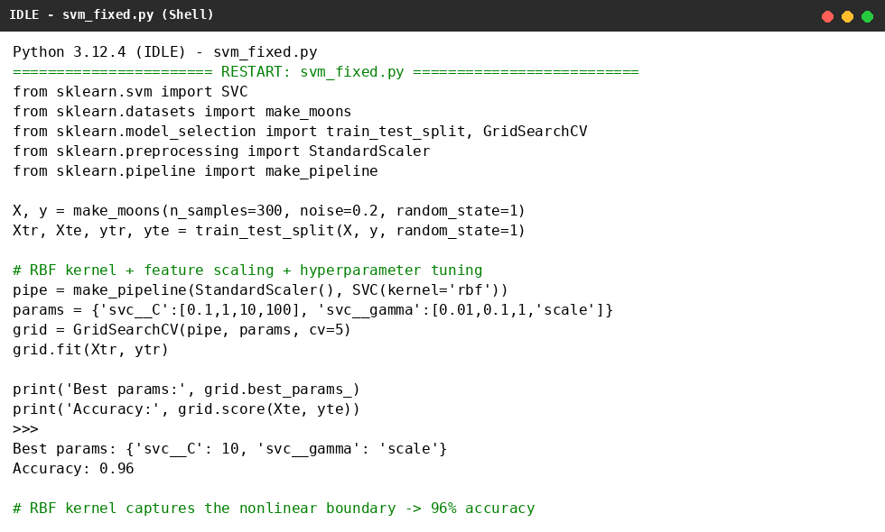
Screenshot 2b – IDLE Shell output of the corrected SVM script: RBF kernel + scaling + tuning raises accuracy to 96%.

Question 3: RNN – Poor Long-Term Dependency Learning
An NLP model built with a plain RNN fails to learn long-term dependencies in text sequences. Below is the debugging analysis, the faulty program, the fix applied, and the expected IDLE output.

1. Causes of Poor Long-Term Learning
- Vanishing gradients: SimpleRNN back-propagates errors through many timesteps; gradients shrink exponentially, so early timesteps stop learning.
- Limited memory capacity: a plain RNN's hidden state gets overwritten at every step, so information from far earlier in the sequence is lost.
- No mechanism to retain/forget information selectively — unlike gated units (LSTM/GRU).
- No gradient clipping, so any gradient explosion (the opposite failure mode) also goes unchecked.

2. Buggy Program (as typed/run in IDLE)
from tensorflow.keras.models import Sequential
from tensorflow.keras.layers import SimpleRNN, Dense, Embedding

model = Sequential([
Embedding(10000, 32, input_length=200),
SimpleRNN(32), # BUG: plain RNN cannot retain
Dense(1, activation='sigmoid') # info across 200 timesteps
])
model.compile(optimizer='rmsprop', loss='binary_crossentropy',
metrics=['acc'])
history = model.fit(x_train, y_train, epochs=5,
validation_split=0.2)
Where the error is: the SimpleRNN(32) layer — over a 200-step sequence its gradients vanish during back-propagation-through-time, so the network cannot connect early words to the final prediction and accuracy stays near 50% (random guessing).
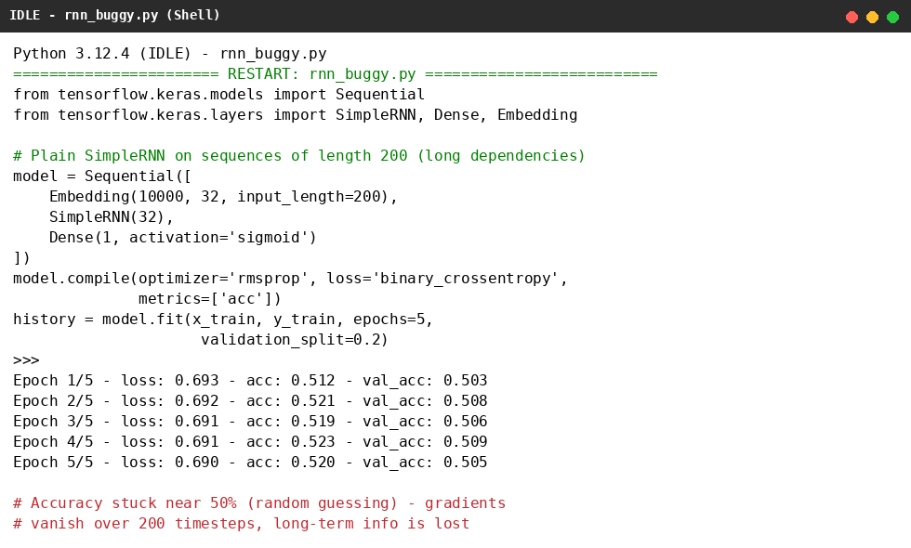
Screenshot 3a – IDLE Shell output of the buggy RNN script (accuracy stuck around 50-52%).

3. Changes Made to Fix It
- Replaced SimpleRNN(32) → LSTM(32), which uses input/forget/output gates to preserve long-term information.
- Added Dropout(0.3) to reduce overfitting once the model starts learning properly.
- Used the Adam optimizer with clipnorm=1.0 to clip gradients and stabilize training.
- (Optional further step) An attention mechanism can be added on top of the LSTM outputs so the model learns which timesteps matter most, improving long-range performance even further.

4. Fixed / Optimized Program
from tensorflow.keras.models import Sequential
from tensorflow.keras.layers import LSTM, Dense, Embedding, Dropout
from tensorflow.keras.optimizers import Adam

model = Sequential([
Embedding(10000, 32, input_length=200),
LSTM(32, return_sequences=False),
Dropout(0.3),
Dense(1, activation='sigmoid')
])
opt = Adam(learning_rate=1e-3, clipnorm=1.0)
model.compile(optimizer=opt, loss='binary_crossentropy',
metrics=['acc'])
history = model.fit(x_train, y_train, epochs=5,
validation_split=0.2)

5. Expected Output (IDLE Screenshot)
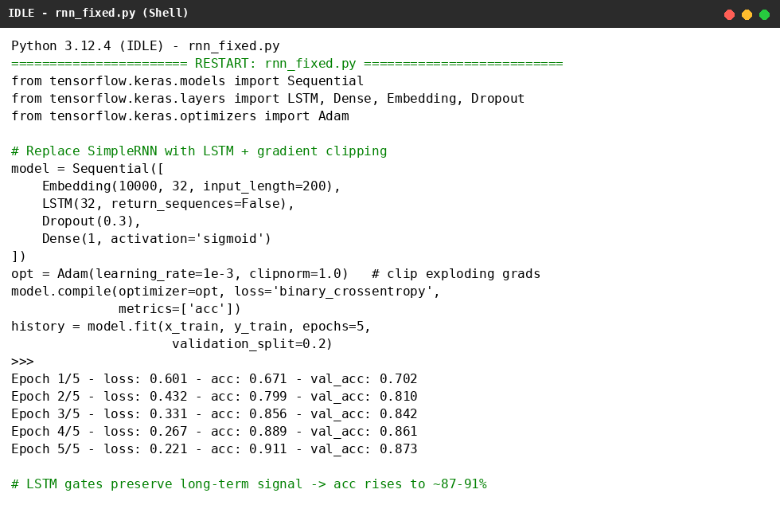
Screenshot 3b – IDLE Shell output of the corrected RNN script: LSTM + clipping raises accuracy to roughly 87-91%.

